Star Schema Documentation

3.

fact_don table

|  |  |  |
| --- | --- | --- |
| **Column** | **Data Type** | **Description** |
| d_id | number | Foreign key to dim_date table |
| a_id | number | Foreign key to dim_address table |
| v_id | number | Foreign key to dim_volunteer table |
| donation_amount | number(10,2) | Dollar amount that was donated |

dim_date table

|  |  |  |
| --- | --- | --- |
| **Column** | **Data Type** | **Description** |
| d_id | number | Primary key of date dimension table. Foreign key to fact_don table |
| Donation_date | date | Date that donation was made |

dim_address table

|  |  |  |
| --- | --- | --- |
| **Column** | **Data Type** | **Description** |
| a_id | number | Primary key of address dimension table. Foreign key to fact_don table |
| address_id | number | Foreign key to address table. |
| street_number | number | Street number of donor’s residence |
| street_name | varchar2(24 byte) | Street name of donor’s residence. |
| postal_code | char(7 byte) | Postal code of donor’s residence |
| city | varchar2(16 byte) | City of donor’s residence |
| province | char(2 byte) | Province of donor’s residence |

dim_volunteer table

|  |  |  |
| --- | --- | --- |
| **Columns** | **Data Type** | **Description** |
| v_id | number | Primary key of volunteer dimension table. Foreign key to fact_don table |
| volunteer_id | number | Foreign key to volunteer table |
| first_name | varchar2(16 byte) | First name of volunteer |
| last_name | varchar2(16 byte) | Last name of volunteer |
| group_leader | number | ID number of group leader. Foreign key to volunteer table. |

The fact and dimension tables are constructed based on the definition of the grain. In this case, the grain is a combination of the day the donation was made, the address of the donor, and the which volunteer collected the donation. We can determine through the grain that the dimensions will be “dim_date”, “dim_address”, and “dim_volunteer”. The fact table contains the quantitative value that connects these three dimensions, which is the donation amount. The donation amount is stored in “fact_don”, along with the foreign keys of the three dimension tables.

The level of detail in the dimensions is based on both the granularity of the star schema, and what information is needed for the different views. The first view displays the average and sum of donations based on day, month, and year. Therefore, the “dim_date” table will need the entire date value from the donation table.

The second view displays the average and sum of donations based on address and postal code. Because the entire address is needed, the level of detail required is significant, resulting in including the entire address table in the address dimension table.

The third view displays the average and sum of donations based on volunteer and volunteer group leader. Again, the amount of information about the volunteer is not specified, so all information from the volunteer table is included in the volunteer dimension table.

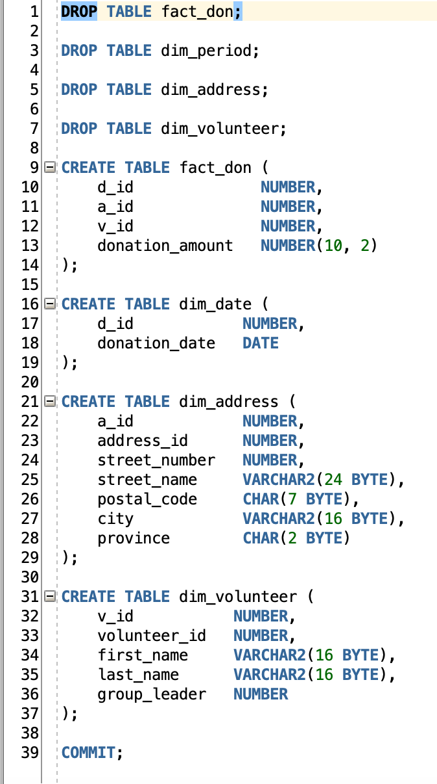

4.

The star schema needs to be loaded with the data collected and filtered into the central repository table. Sequences need to be created for all three dimension tables in order to create autoincrementing integers that will serve the tables primary keys.

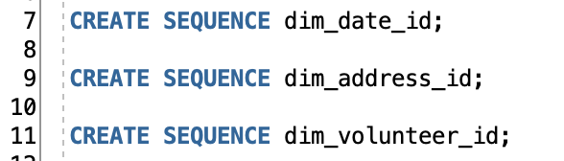

Once the sequences are created, they are used to create the surrogate keys of the dimension tables every time they are called using “.NEXTVAL”. This will be used within a SELECT statement to populate the dimension tables and assign them with unique ID values.

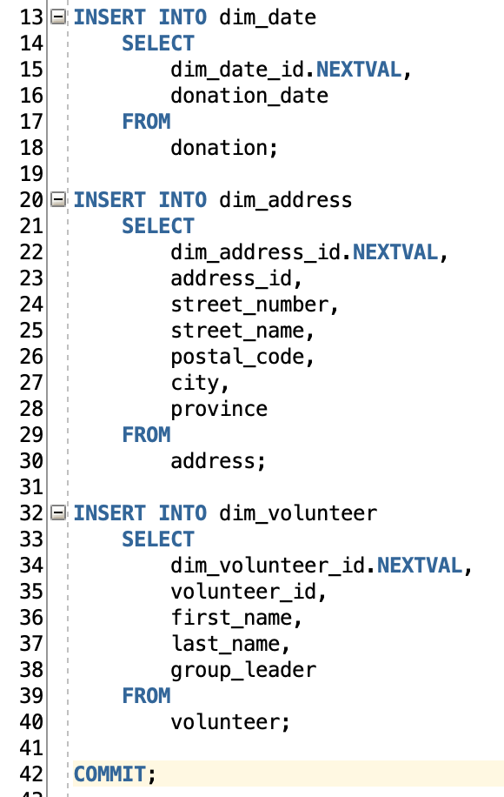

The following PL/SQL script is used to populate the fact_don table. An array records found in the fact_don table is created, with the attribute %rowtype to store each row as they are represented in the database.

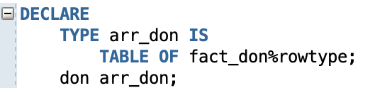

A cursor is used to traverse the array, selecting every column in the fact_don table and retrieving the data needed to populate it from the main donation table and the different dimension tables through consecutive INNER JOINs.

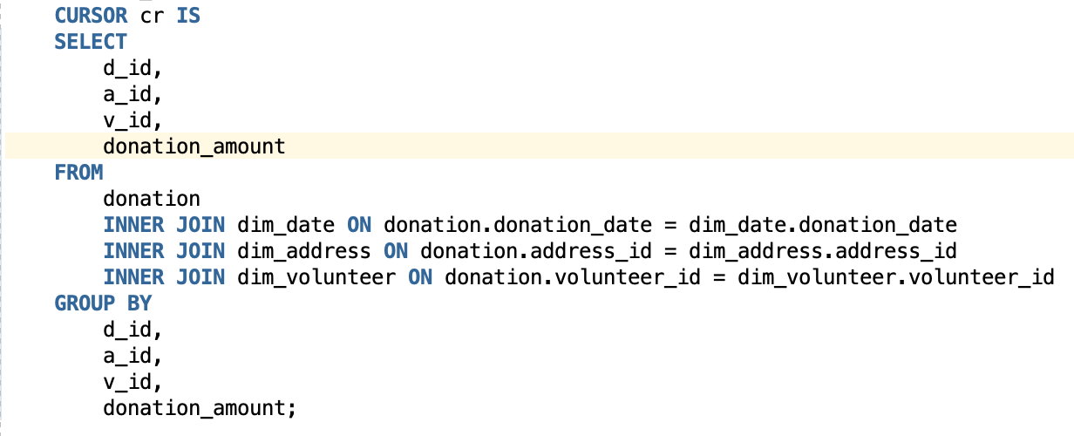

The cursor is opened, and a BULK COLLECT is performed to traverse the array and insert all the values into the fact_don table. Once the process is complete, the transaction is committed, and the block has ended.

